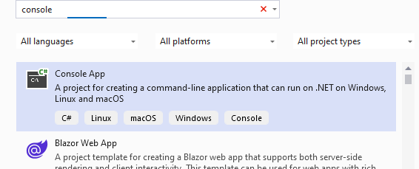



**Step no 1. Use console app for this code ,then select the name ,next, then use .NETapplication which come automatically then next , and inside the console(hello world!) roemove it and put this code there .**

**Practical No:- 1**



**Aim:** Design ui based application using basic windows forms controls, using classes and objects design applications, using inheritance and abstract classes.

#1Design UI based application using basic windows forms controls.

* 1. Write a program in c# to print( console base(CUI)): Factorial of a number
  2. even or odd
  3. prime number or not
  4. reverse of a number
  5. Factorial of a number

TYPE2 QUESTION:

Another one is

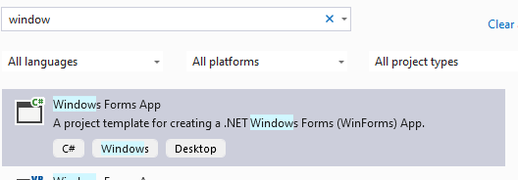

Next, Next then create

INSIDE THIS WE USE MYSQL CONNECTOR AND IT WILL DISPLAY IT ON LOCALHOST

THIS APPROCH WILL GIVE THIS



